IDEATION PHASE
Brainstorm & Idea Prioritization Template
Date | 31 January 2025
Team ID | 6ab6179bdcoae83adb386708 (Team 6)
Project Name | Auto Ticket Classification using Flow Designer
Maximum Marks | 4 Marks

Brainstorm & Idea Prioritization
Brainstorming provides a free and open environment where all team members can contribute ideas for solving the support-ticket management problem. The team focuses on generating multiple practical ideas first and then prioritizes them based on impact, usefulness and implementation effort. The ideas below are specifically related to the project "Auto Ticket Classification using Flow Designer".
Step-1: Team Gathering, Collaboration and Select the Problem Statement
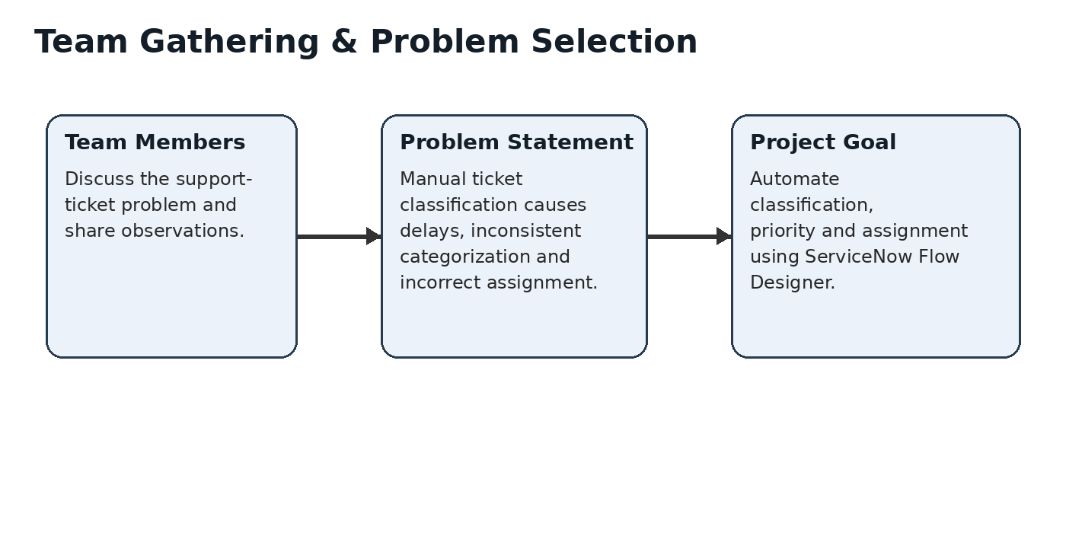
Problem Statement: Support teams often receive incidents that must be manually reviewed, categorized, prioritized and assigned. This manual process can cause delays, inconsistent classification and incorrect routing of tickets. The project aims to automate these actions using ServiceNow Flow Designer.
Step-2: Brainstorm, Idea Listing and Grouping
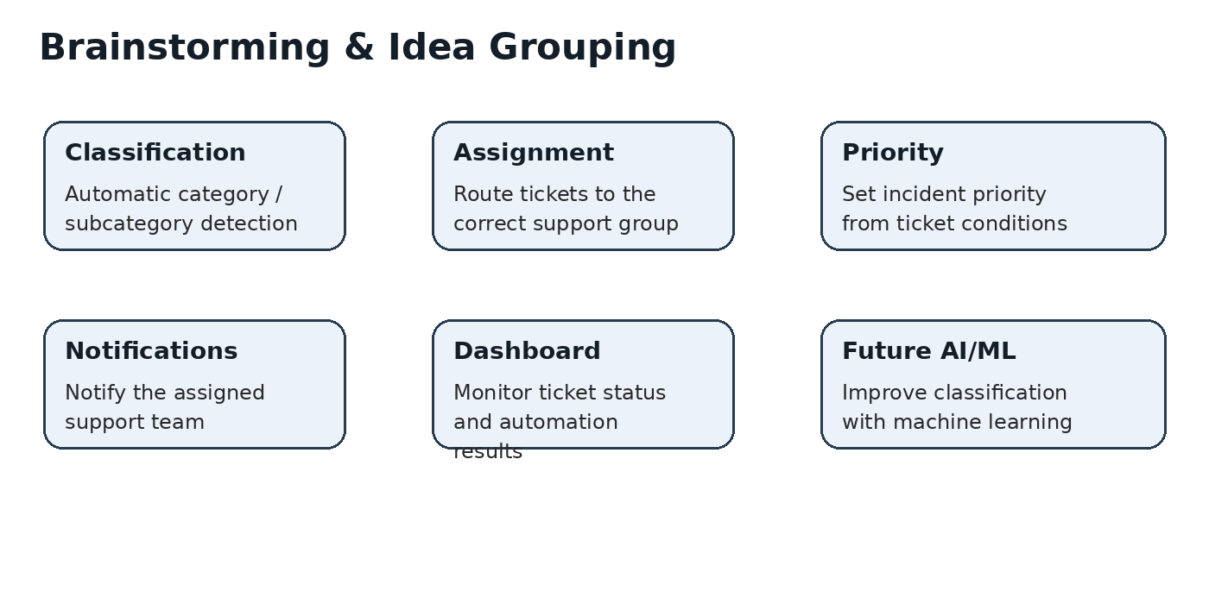
Idea | Description | Group
Automatic ticket classification | Automatically identify the category and subcategory from the incident details. | Core automation
Automatic assignment | Route the ticket to the correct support group based on its classification and conditions. | Core automation
Automatic priority setting | Set the ticket priority according to predefined conditions such as impact and urgency. | Core automation
Notifications | Notify the assigned support team when a ticket is routed or updated. | Support feature
Ticket monitoring dashboard | Provide a simple view of ticket status and automation results. | Monitoring feature
AI/ML-based classification | Use AI/ML in a future enhancement to improve classification for complex ticket descriptions. | Future enhancement
Step-3: Idea Prioritization
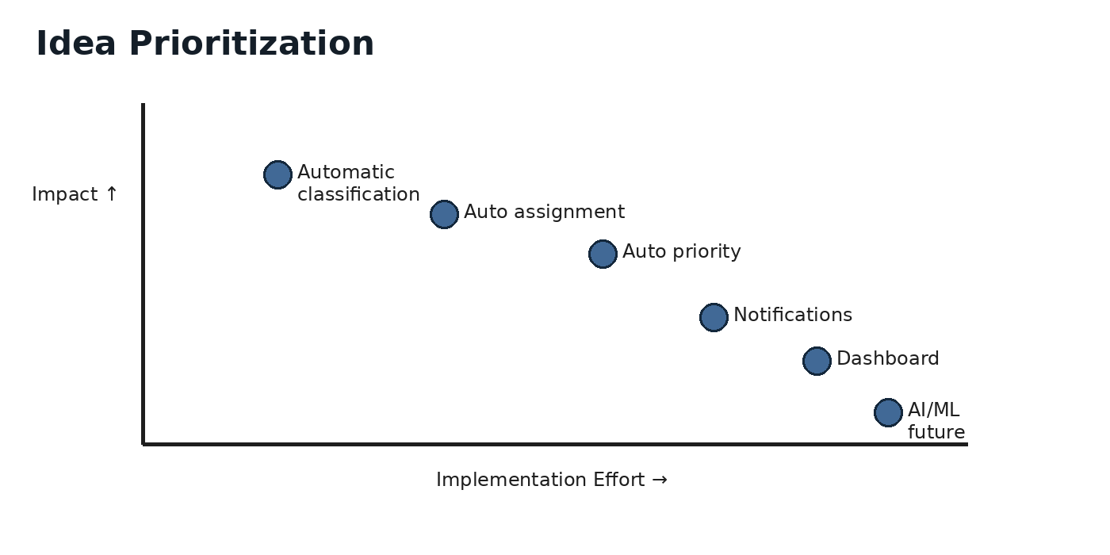
No. | Idea | Priority | Reason
1 | Automatic ticket classification | High | Directly solves the main problem and is the core of the project.
2 | Automatic assignment to the correct support group | High | Reduces manual routing and helps the right team receive the ticket.
3 | Automatic priority setting | High | Helps support teams handle incidents according to predefined urgency/impact conditions.
4 | Notifications to the assigned team | Medium | Improves awareness after a ticket is assigned.
5 | Ticket monitoring dashboard | Medium | Helps monitor tickets and automation outcomes.
6 | AI/ML-based classification | Future | Can improve classification accuracy as a future enhancement.
Selected Solution
Use ServiceNow Flow Designer to trigger when an incident is created. The flow checks the ticket description and relevant conditions, identifies the appropriate classification, and automatically updates the ticket category, priority and assignment group. Notifications and monitoring can be added as supporting features, while AI/ML-based classification is kept as a future enhancement.
Reference: MURAL – Brainstorm & Idea Prioritization Template: https://www.mural.co/templates/brainstorm-and-idea-prioritization

